# CUSTOMER ENGAGEMENT MARKETING

# BMT6144

**Trimester - 4**





***Case Study- Brand Engagement: Social and digital perspective***

**Submitted To:**

Dr SAJU B

Assistant Professor Vit Business School

**Submitted By:**

Aman Kumar - 20MIA1144

Aadi Ashutosh Chauhan - 18BEE1007

. Mayank Gupta - 20BCE1538

Naveen Gupta- 19BCE1791

. Karan Dua - 20BAI1012

Saikiran Reddy - 18BEC100

|  |
| --- |
| contents |

CONTENTS 2

1. Introduction 3

1.1 Methodology adopted 3

2. Definition: What is a brand? 3

3. Social Perspective Of Brand Marketing 3

3.2 Making Nationalistic Appeals 4

3.3 Hitting Emotions by Social work 5

3.4 Bringing Social Change In Perspective 6

4. Negative Implications 7

4.1 Tanishq 7

4.2 Lux Cozi advertisement starring Varun Dhawan 8

4.3 Fair n Lovely to Glow n Lovely 8

5. Digitalization Perspective of Engagement 10

5.1 Why is digital customer experience important? 10

5.2 Digital Engagement Strategies 10

5.3 Case Study For Digital Customer Engagement 11

6. Effective Strategies 13

6.1 How do you build Customer Engagement? 13

7. Conclusion 17

8. References 17

9. Plagiarism Report: 18

## Introduction

### Methodology adopted

Several resources were utilized in summing up the views from different case studies few target questions were answered. Kindly find the reference material links at the end of this document.

## Definition: What is a brand?

A brand is not merely a representation of a product: it is an emotional and symbolic perception we develop that influences our thoughts, feeling, and behaviour.

**What is brand engagement and why does it matter?**

Brand engagement signifies an emotional commitment to a brand. It’s more than brand awareness; it is loyalty and word-of-mouth marketing. Brand engagement is important both internally and externally. Building the brand internally and obtaining employee engagement with the brand helps to further solidify and build the brand ultimately improving the brand for consumers.

Social media has given new meaning to word-of-mouth marketing and the ability for consumers to interact with brands on new levels and build relationships in new ways. Brand engagement goes hand in hand with customer engagement and engaged customers translate to increased revenues, profitability, and market share.

So, does your brand matter? Yes! And, it matters to your employees, your customers, and your bottom line. Surveying your customer base, the market, and your employees, can identify the level of brand engagement that exists today and can identify key action items to increase brand engagement across these key populations.

## Social Perspective Of Brand Marketing

* 1. ***How Brands Form Identity - “Get A Mac” Campaign***

Apple launched its “Get a Mac” campaign. The campaign featured a series of commercials that started out with a young, hip guy in a hoodie introducing himself by saying “Hi, I’m a Mac.” A stodgy, older man wearing a blazer and glasses portrayed another computer brand. The campaign implied that the computer you use signifies the kind of person you are, and of course you want to be young and cool, like a Mac.

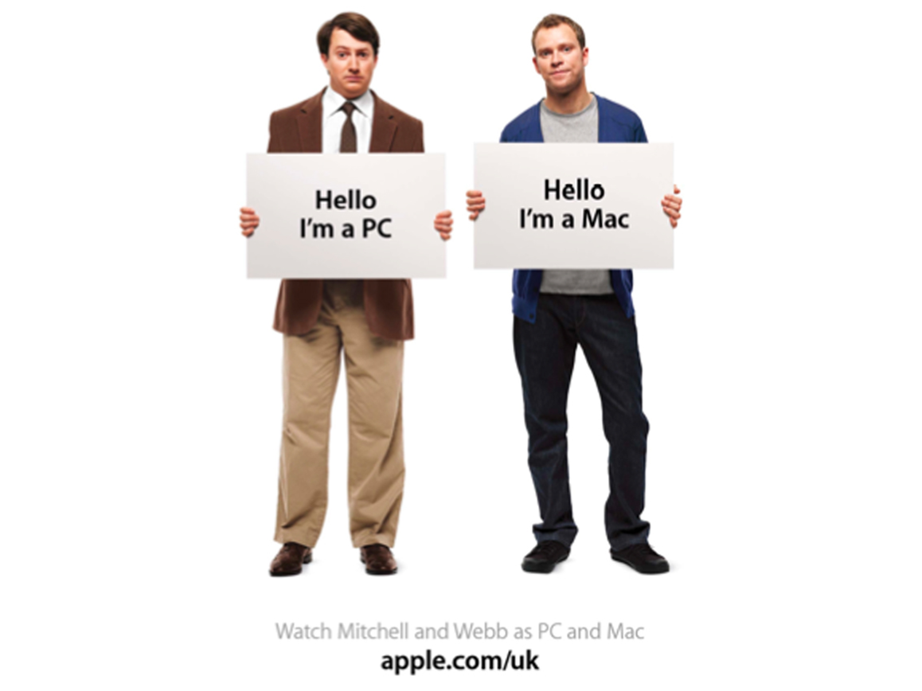 The “Get a Mac” campaign is an example of the use of identity in branding. Identity is an important psychological and social concept that relates to how we view and define ourselves and others

### Making Nationalistic Appeals

#### ULTRATECH CEMENT

Ultratech promotes the tagline like “Desh ka cement” and “Engineers choice” to hit the emotions of the people, they try to relate with customers patriotic feelings.



UltraTech Cement focuses on **aggressive** promotion strategy in its marketing mix. It depicts strong bond between the customers and the brand that has significant relationship developed over the years**.**

UltraTech Cement Limited is the largest manufacturer of cement in India and ranks among the world's leading cement makers. UltraTech's vision is to be **'The Leader' in Building Solutions**. The company has a consolidated capacity of 116.8 million tonnes per annum (MTPA) of grey cement.

### Hitting Emotions by Social work

#### Nihar Shanti Oil

In the Nihar Shanti advertisement staring Vidya balan, it tries to hit the emotions of the customers by saying that if they buy one bottle they can help one poor child.



Nihar Naturals has rolled out a new campaign for its Shanti Amla hair oil. The film has been conceptualised by BBH India and features brand ambassador and Bollywood actor Vidya Balan.

Nihar Naturals Shanti Amla has undertaken the cause of children’s education at the heart of its existence. Embarking on this mission four years ago to make education accessible to children across India, the brand contributes 5% of its profits towards children’s educational development, thereby becoming an enabler for consumers to make a positive change to the society.

### Bringing Social Change In Perspective

#### Cadbury

These are two very different eras. Back then, we were just in the early days of liberalization, so there was optimism in the air. And in those days, it was normal to see men breaking into a cricket field and running to the center. Watching a woman do it was something that delighted people, it was freedom of a certain kind. And today we have come a long way from seeing men play cricket, our girls are doing so well. Thus, the role reversal becomes the idea.

# 

## **Negative Implications**

### Tanishq

In this advertisement tanishq had a positive intention of showcasing the unity among the Hindu’s and Muslim’s but the advertisement was misunderstood and tanishq was blamed of promoting “Love Jihad”

Thus, Tanishq had to withdraw the adv.



### Lux Cozi advertisement starring Varun Dhawan

The Varun dhavun was trolled a lot recently as this advertisement had some not moral meanings this can be considered as differences in mindset of people belonging to different generations.



### Fair n Lovely to Glow n Lovely

The new name, GLOW & LOVELY, remove references to "whitening" or "lightening" on the products, which are sold across Asia.

# 

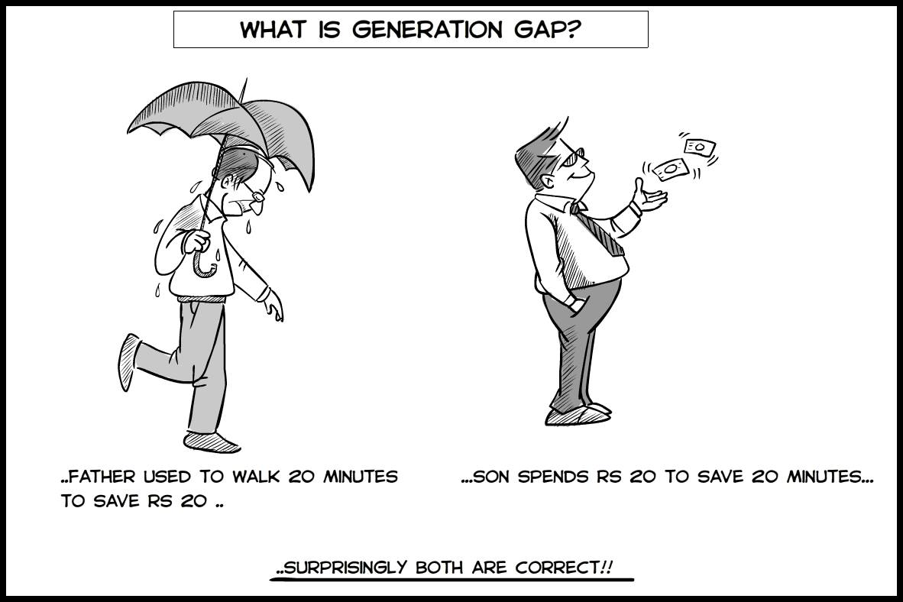

This table here is an example taken of my family, we are three generations living under the same roof, we have different thinking about a product and different aspects of liking a product.

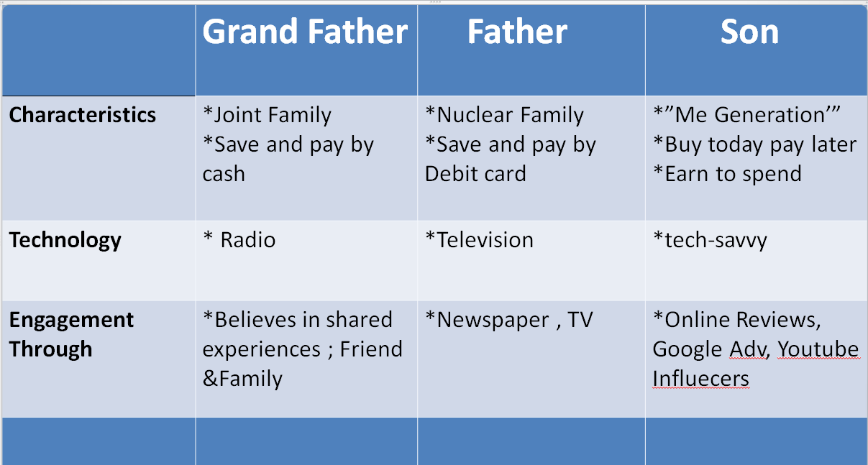

## Digitalization Perspective of Engagement

It’s like digital engagement with customers and inspiring them to urge involved within the experiences that a brand has created digitally for them. Digital engagement may be a process of building a relationship with a possible customer through various digital channels.

The customer engagement process begins with the primary contact. It involves cultivating a relationship with a customer through a series of interactions that will be initiated and maintained throughout their journey.

Digital engagement may be a process that involves creating digital experiences for patrons. It helps them become involved in the journey of the brand.

Through digital channels, consumers can buy products and services wherever they're and interact with brands in a sort of way.

### Why is digital customer experience important?

Today’s consumers are first and foremost digital customers. They believe in various digital channels to navigate and communicate with brands. So, brands must engage customers digitally to fill the gaps within the customer’s journey.

### Digital Engagement Strategies

In today’s digital world, Brands got to continue with a shift in consumer habits and behaviors. The brand has got to choose better thanks to the engaging customer with their product and knowledge and therefore the best way is to plug them on digital platforms and social experiment.

Brands have to consistence and make quality experience with consumer while engaging digital.

**Here are a number of the customer engagement strategy should take into consideration:**

1.Behaviour-based messaging, Marketers can leverage the facility of technologies like live chat to create stronger engagement strategies.

2. Through social media, brands can forge their personalities and appeal to customers across demographics. It’s not merely a platform for connecting anymore; it is a digital space where brands can engage with customers through support channels, live-chat, sharing content, and more.

3. Provide customers with self-service options like AI chatbots which will answer various questions and direct customers to a person's agent when necessary.

4. A library of multimedia resources that customers can use as a reference when needed.

5. Customers’ feedback is crucial to the success of your engagement strategy. It helps you learn what triggers your customers into making a sale decision and taking other actions.

6. Personalize the digital advertisement to interact with the buyer.

To establish loyalty, you now need to keep your customers interested – and that means keeping them engaged.

When it’s come to relationships between brands and their customers then brands have to make sure that capitalize on this practice and get digital customer engagement right,

* **Be conversational.** Make sure you get a both way engagement with your customers, encourage sharing, reactions, and comments.
* **Be omnichannel.** Adopt a unified customer view and be there for your customers anytime and anyplace they needed.
* **Be personal.** Use data to create unique experiences and show customers that your company “remembers” the previous interactions you’ve had with them.
* **Be real time.** Train your team to respond quickly and use automation where needed to make sure you never leave your customers hanging.
* **Be tech-savvy.** Choose the best tools to gather and analyze data and communicate with your customers.

### Case Study For Digital Customer Engagement

#### Harris Teeter Case Study

National grocery and pharmacy chain [Harris Teeter](http://www.harristeeter.com/) approaches single grain, digital marketing agency to take help and engage customer to their product through digital platform.

The challenge in this case was the fact that there wasn’t much room for error. Grocery businesses have razor-thin profit margins, which means that every dime they invest into marketing needs to have a strong likelihood of producing a return. There’s not much to waste.

In addition to that, most grocery stores customers are located within a short distance from the grocery store of choice and don’t tend to venture further. These customers are also quite price sensitive.

They started off by testing a variety of different ad creatives, targeting segments, and placements. This helped us find a few combinations that delivered the most visibility for Harris Teeter in terms of social media fan base. Once the fan base was established, we started growing the engagement rates of posts.

The strategy they (agency) used to get in front of new customers was behavioural targeting. We implemented geographic targeting of ads, Lookalike Audiences, and Optimized Cost Per Mille bidding to stretch ad dollars the furthest.

On social media, images become “stale” faster than they do on other channels because of the speed of content consumption on social platforms, so we rotated fresh images more frequently.

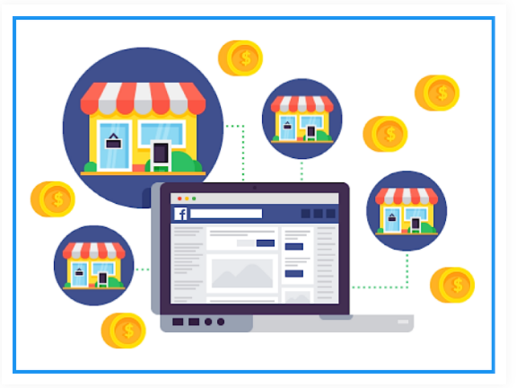

## Effective Strategies

**Digital customer engagement:**

Digital engagement is the process of interacting with potential and existing customers through various digital channels to build your relationship with them. These channels include email, messaging, social media, and many more.

The business and customer engagement process usually begins with the first point of contact and extends throughout the customer journey. It involves proactive interactions that effectively boost engagement with customers in the online spaces they frequent to consume content or communicate

### How do you build Customer Engagement?

* You’ll need to implement a customer engagement strategy
* Boost digital customers’ engagement with personalized experiences and digital marketing
* Use a customer engagement platform

Example:

#### Netflix

The reason why Netflix proves such a powerful example of customer engagement is their focus on personalising customer experience. By investing heavily in algorithms and audience analytics, Netflix has been able to offer an on demand service that’s unique for each viewer. As their [director of global communications](https://www.nytimes.com/2013/02/25/business/media/for-house-of-cards-using-big-data-to-guarantee-its-popularity.html) explains, there are now ‘33 million different versions of Netflix.’



**Takeaway:** To learn from this customer engagement example, aim to go beyond your customers wants by studying customer activities and preferences. By analysing the habits of your current customers, you can learn how to evolve and better market your product.

#### Gymshark

The reason why Netflix proves such a powerful example of customer engagement is their focus on personalising customer experience. By investing heavily in algorithms and audience analytics, Netflix has been able to offer an on demand service that’s unique for each viewer. As their [director of global communications](https://www.nytimes.com/2013/02/25/business/media/for-house-of-cards-using-big-data-to-guarantee-its-popularity.html) explains, there are now ‘33 million different versions of Netflix.’



**Takeaway:** To learn from this customer engagement example, aim to go beyond your customers wants by studying customer activities and preferences. By analysing the habits of your current customers, you can learn how to evolve and better market your product.

#### Apple

The reason why Netflix proves such a powerful example of customer engagement is their focus on personalising customer experience. By investing heavily in algorithms and audience analytics, Netflix has been able to offer an on demand service that’s unique for each viewer. As their [director of global communications](https://www.nytimes.com/2013/02/25/business/media/for-house-of-cards-using-big-data-to-guarantee-its-popularity.html) explains, there are now ‘33 million different versions of Netflix.’



**Takeaway:** To learn from this customer engagement example, aim to go beyond your customers wants by studying customer activities and preferences. By analysing the habits of your current customers, you can learn how to evolve and better market your product.

#### Starbucks

After resuming operations, Starbucks discovered that its rapid expansion had diverted attention away from the problem.

Starbucks offered co-creating chances in order to repair consumer relationships and demonstrate that it cared about them through quality and consistency. It launched "My Starbucks Idea," which allows users to contact employees directly. This approach resulted in the formation of like-minded communities, such as the 'Free Wi-Fi group' or the 'Comfy Chair Group.' In addition, the coffee chain was able to implement over 100 new ideas, rebuilding customer faith in the brand.

.

Starbucks has taken advantage of every available chance to engage its customers. Customers can draw creative artwork on simple red cups as canvas and upload them on Instagram/Twitter with the hashtag #RedCupArt. Positive word of mouth increased the value.

**Mobile Apps (2017):** As mentioned before, Starbucks had a great deal of investment in digital transformations technology. They have entered the mobile phone application space well before their competitors. This was a great leap considering the bottom line of the coffee chain. However, the application still encompassed the store-locator and ‘nutrition-based information’ along with the feature to order online. The home-delivery service option had its utmost relevance in the course of the pandemic. In this case, the ambience/experience is now witnessed as an online store attribute and happy taste/delivery experience. In the first place, the app was designed to appeal to its target audience and form an online community. The engagement is possible was ensured via reward programmes.

**Social Media Strategy & Creating Trends:** The promotions encouraged the idea of having a casual breakfast at Starbucks which significantly increased the customer visits around 10.30 am. Not only did this created the online-order-traffic but people across America queued up at the outlets.

**Product-Based Campaigns:** With the co-creation, Starbucks invents new flavours and celebrates them with customers via online campaigns: They have created social accounts for pumpkin spiced latte and Frappuccino, where they post relevant memes for their diehard fans.

**Social Message:** Besides altering the internal competencies, their digital presence and contributions are held for good cause: For instance, #ExtraShotOfPride campaigns support the LGBTQ+ community.

## Conclusion

Brand engagement signifies an emotional commitment to a brand. It's more than brand awareness, it is loyalty and word-of-mouth marketing The increasing use of social media has changed how firms engage their brands with consumers in recent times social media brand pages have become instrumental in enabling customers to voluntarily participate in providing feedback and ideas for improvement and collaboration with others that contribute to the innovation effort of brands where the social brand engagement uses a different type of methodologies like using identity in branding, making nationalistic appeals and hitting with emotions both social and digital brand engagements have their pair of advantages and disadvantages like negative implication in social brand engagement and getting into connection with people at backwards areas where digitalization is nearly not possible the main conclusion is "Effective marketing depends upon what we say”.

## References

* + 4th Edition of Strategic Brand Management by Richard Rosenbaum-Elliott, Larry Percy & Simon Pervan
  + Regaining “Lost” Customers: The Predictive Power of First-Lifetime Behavior, California State Polytechnic University, V. Kumar (2015)
  + Case Study: Apple, Netflix , Starbucks, Karthleen Lee
  + An Analysis On Brand Loyalty: A Case Study On Starbucks, *Spring, California State Polytechnic University*, Kavita Kumar (2016)
  + Recapturing Lost Customers, World Scientific, Journal of Market Research Jacquelyn S. Thomas, Robert C. Blattberg, Edward (2004)

[Referral Post](https://www.google.com/search?q=starbucks%2Breferral%2B&tbm=isch&ved=2ahUKEwiY0Jvj3IHzAhVEAisKHSYBBdEQ2-cCegQIABAA&oq=starbucks%2Breferral%2B&gs_lcp=CgNpbWcQAzIHCCMQ7wMQJzIHCCMQ7wMQJzIECAAQHjIECAAQGDIECAAQGDIECAAQGFDq7wFYzPoBYLODAmgAcAB4AYABhwGIAe8GkgEDOS4xmAEAoAEBqgELZ3dzLXdpei1pbWfAAQE&sclient=img&ei=90pCYdj4HcSErAGmgpSIDQ&bih=722&biw=1536&imgrc=ibevHU90BH1soM)

<https://stories.starbucks.com/stories/2016/starbucks-invites-customers-to-create-red-cup-art/>

[https://digital.hbs.edu/platform-digit/submission/starbucks-winning-on-rewards-loyalty-and-](https://digital.hbs.edu/platform-digit/submission/starbucks-winning-on-rewards-loyalty-and-data/) [data/](https://digital.hbs.edu/platform-digit/submission/starbucks-winning-on-rewards-loyalty-and-data/)

## Plagiarism Report:

Sections: 1 – 3.3: 946 Words Sections: 3.3 continuation – 4:918 Words

